**SURVEY METHODOLOGY**

**Survey:**

The research method which is used to collect data from selected groups of respondents in order to collect information regarding some areas of interest is known as survey. A survey can have different purposes and it can be conducted in a variety of ways. These ways depend upon the selected methodology and the study goal that we want to achieve.

**Survey Methodology:**

The techniques, tools or processes that can be used to conduct surveys from specific groups of people are known as survey methods.

**Classification of Survey Methods:**

The survey methods can be classified into three major categories. These categories have a specific purpose and can be used in a particular type of way. These are:

·         **Exploratory research**

This type of research mainly focuses on the discovery of ideas and insights as they are opposed to collecting the data statistically. This type of research usually consists of open-ended questions. They are not measurable statistically but can provide a wide range of information.

·         **Descriptive research**

This is a type of research which can take a bulk of surveys and it is considered conclusive because of its quantitative nature. They are preplanned and well structured in design so that they can be measured statistically.

·         **Casual research**

This is the type of research which is preplanned and well structured in design. It is considered conclusive as it can be used to explain the cause and effect relationship between the variables.

**Types of Survey Research Methods:**

There are different types of survey methods that can be used. These are:

* ·         **Cross-sectional studies:**

It is described as a sort of observational study that evaluates data on variables collected across a sample population at a certain point in time. It is a quick method and can be used to collect information in a short span of time.

* ·         **Correlational studies:**

It's a non-experimental research methodology in which two different variables are researched and statistical analysis is used to investigate the relationship between them without the use of "variables" from external study.

* ·         **Longitudinal studies:**

It is a type of observational research that uses continuous or recurring measures to track specific individuals across time, usually years or decades.

**Data Collection Methods:**

There are different methods that can be used to collect data. Few data collection techniques include:

* ·         **Paper surveys**

These surveys are a fantastic way to get feedback from those who don't have access to a phone, internet, or mobile devices, or who won't respond to other types of surveys.

* ·         **Face to face surveys**

An interviewer is physically present to ask the survey questions and help the respondent in answering them in a face to face survey.

* ·         **Telephone surveys**

In this strategy, professional interviewers use telephone numbers to call and acquire information from potential respondents.

* ·         **Online surveys**

An online survey is a questionnaire that may be completed by the target population over the internet. They're commonly built as Web forms with a database for storing replies and statistical software for providing analytics.

**Process of Conducting a Survey:**

There are different steps that are involved in the process of conducting surveys. It includes:

* ·         The first stage in survey research is to define the study's purpose and aim, such as the problem, why conduct the research and what value it adds, and how to formulate clear objectives.
* ·         Choosing and defining the target population, or the people who will be studied.
* ·         Choosing and evaluating data collection procedures. (i.e. the data collecting tool, such as an interview or a questionnaire). The cost, applicability, and study design all factor into the instrument selection.
* ·         A significant and representative (sample) of the population should be taken (i.e. this is the step of sampling).
* ·         The data collection procedure (or simply the stage of carrying out the research), in which interviews, questionnaires, or any other instrument with pre-designed questions is utilized.
* ·         If a questionnaire was employed, it was followed up on. The interviewee's questions are answered and assessed, and the data collection procedure is thus concluded.
* ·         The acquired data is processed, evaluated, and interpreted, after which the findings are concluded and generalized.
* ·         The entire study is then published in the form of a research report (also known as a survey report) for dissemination and future investigation.

As a result, the survey study is finished by completing the aforementioned procedures.

**Advantages of Questionnaires:**

There are certain advantages of using a questionnaire. Questionnaires is the economical method of conducting a survey. It can cover a wide range and is a quick way of conducting the research. It puts less pressure on the respondents and creates a uniformity among all the responses. It can provide validity and anonymity among the respondents. It can be measured easily and is considered to be the most effective tool for considering the data.

**Selected Method:**

In our report, we have used the descriptive research method which means that we are collecting data through questionnaires and close ended questions. The data is quantitative and we have used paper surveys to collect the information.

**Introduction**

Before moving on to the actual topic, let us define a few terms used.

* **Teachers and Teaching**

The word teacher is derived from the Proto-Germanic word ”taikijan” which means “to show, point out, or to demonstrate”. A teacher is a person whose occupation is to help students to learn and to gain knowledge. A teacher is also called an instructor, or an educator.

In 1939, John Brubacher defined teaching as “Teaching is arrangement and manipulation of a situation in which there are gaps or obstructions which an individual will seek to overcome and from which he will learn in the course of doing so”.

Robert Glaser developed the Basic Teaching Model in 1962, which explains the four steps involved in the structure of teaching are as follows:

1. Instructional Objectives: Defining the objectives that the students should be achieved as a result of the teaching.
2. Entering Behaviour: Accessing the previous knowledge of the students before they start the teaching process.
3. Instructional Procedures: Designing content and strategies of teaching based on instructional objectives and entering behaviour.
4. Performance Assessment: Assessing the outcomes of teaching. The purpose of this step is to give feedback on the teaching process. Based on the feedback given, step 1 and step 3 may be repeated and the process is assessed again.

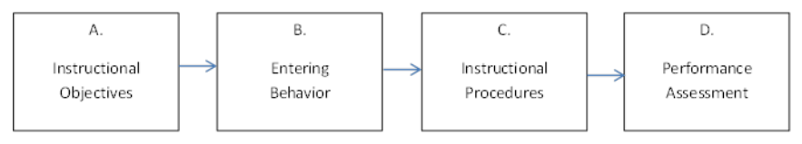

* **Types of Teaching Methods**

There are four basic types of teaching methods:

1. Teacher Centred: In the teacher centred method, the teacher is considered the “authority figure” and the students look upon their teachers as a master of the subject. In this approach, the students are considered as “empty vessels” that gather information from their teachers. At the end, the learning of the students is measured using scored assessments. For example, lecture methods.
2. Learner Centred: In the learner centred method, the teacher is considered as a “guide on the side” and acts as a resource rather than an authority. According to Lawrence Stenhouse, in the learner centred method a teacher is both a teacher and a student simultaneously. “So that in his classroom extends rather than constricts his intellectual horizons”. For example, discussion methods.
3. High Tech: In high tech methods, technology is used to help the students in the process of learning in the classrooms. Some examples of the technologies used are computers, tablets, laptops, and the internet. For example, flipped classrooms in which students watch recorded lectures at home and do assignments in the classroom.
4. Low Tech: Along with the advantages of using technologies, there are also some disadvantages. For example, the continuous use of spell correction can cause the students to forget the spellings of words. Considering the disadvantages of using technology in classrooms, in low tech methods, the use of technology is avoided in classrooms. For example, the direct instruction method in which lectures and lesson plans are used to teach the students.

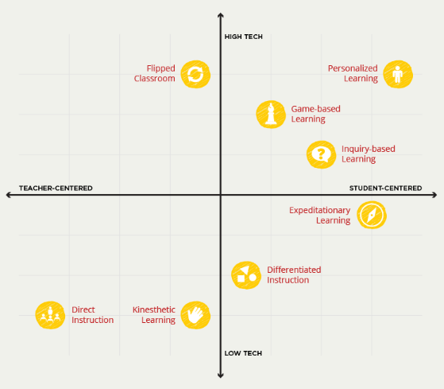

* **Behaviour**

The definition of behaviour in the dictionary of psychology is “the activity of an organism interacting with its environment”. The term refers to any observable activity performed. The concept was first introduced by John B. Watson in 1913 in the United States and has its link with the Behaviourism school of thought presented by Watson. It is the actions performed by an individual to make something happen or to keep something the same as a response to a stimulus. Neveanu in 1978 explained behaviour as “adaptive responses assembly that a body equipped with the nervous system performs as a response to the stimuli of the environment which are also objectively observable”.

* **Types of Behaviours**

The types of behaviours are as follows:

1. Molecular and Molar Behaviour:

Molecular Behaviour: The behaviour that occurs unexpectedly without a thinking process. For example, you close your eyes when someone is about to hit you.

Molar Behaviour: The behaviour that occurs after thinking. For example, you counter attack when someone attacks you.

1. Overt and Covert Behaviour:

Overt Behaviour: The behaviour that is visible. It occurs outside the human body. For example, riding a bicycle.

Covert Behaviour: The behaviour that is not visible. It occurs inside of the human body. For example, thinking

1. Voluntary and Involuntary Behaviour:

Voluntary Behaviour: The behaviour that occurs due to human want. For example, eating and drinking.

Involuntary Behaviour: The behaviour that occurs naturally. For example, breathing.

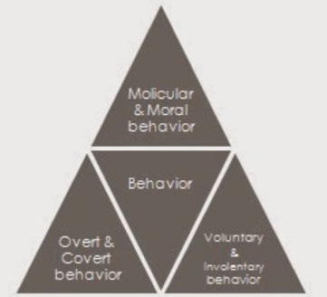

* **Teachers’ Behaviour**

According to Ryan, teachers’ behaviour is defined as “the activities of a teacher that are done as and when required for guiding and directing pupils' learning”. It is the actions performed by the teachers during their interactions and communications with the students.

* **Assessment of Teaching Behaviour**

Teachers’ behaviour with their students can be assessed in three possible ways:

1. Teacher reports: In teacher reports, teachers self assess their teaching behaviour by usually filling a questionnaire. One of the disadvantages of the method is that the teacher report may be plagued as teachers are themselves reporting their behaviour.
2. Classroom observations: In classroom observations, trained observers observe teachers behaviour with students while they are teaching. The reports are not plagued as in the case of the teacher report as the observation is carried out by external observers. But the problem with the classroom observation method is that it is time consuming and costly.
3. Student reports: In student reports, the students themselves report the teaching report. This method solves the problem of teacher reports of being plagued and that of classroom observations of being cost and time consuming.

Considering the benefits of the student reports method, the method used for the assessment of teaching behaviour in this survey is student reports.

* **Psychological Development**

Psychological Development is defined as “the development of human beings’ cognitive, emotional, intellectual, and social capabilities and functioning over the course of a normal life span, from infancy through old age”. According to Erik Erikson, an ego psychologist, the stages of psychological development of a person are as follows:

* Trust or Mistrust

The first stage of psychological development occurs during infancy(birth to 18 months). If the infant is given proper care and love, they develop trust. If proper care and love is not given, it can lead to mistrust in the infant.

* Autonomy or Shame and Doubt

The second stage of psychological development occurs during early childhood(2 to 3 years). At this stage the child is developing personal control and independence. If the child is given independence to make choices, they develop a sense of autonomy. Otherwise, it can lead to shame and doubt in the child.

* Initiative or Guilt

The third stage of psychological development occurs during preschool(3 to 5 years). At this stage, the child begins to assert their control while playing and during other interactions. Success at this stage leads to the child learning to take initiative. A child who asserts too much control faces objection which leads to Guilt.

* Industry or Inferiority

The fourth stage of psychological development occurs during school age(6 to 11 years). If a child is encouraged and appreciated for his achievement, they develop a sense of competence. If a child is not appreciated, he/she develops a sense of inferiority.

* Identity or Confusion

The fifth stage of psychological development occurs during adolescence(12 to 18 years). During this stage, the adolescent is developing a sense of personal identity. Succeed at this stage leads to a strong and positive sense of personal identity. Failure at this stage leads to confusion.

* Intimacy or Isolation

The sixth stage of psychological development occurs during young adulthood(19 to 40 years). Young adults are required to form intimate relationships. Failure in doing so leads to isolation.

* Generativity or Stagnation

The seventh stage of psychological development occurs during middle adulthood(40 to 65 years). An adult is expected to build both their personal and professional lives. Those who are successful have a sense of generativity. Those who fail develop a sense of stagnation i.e. not contributing to the world.

* Integrity or Despair

The eighth stage of psychological development occurs during maturity(65 years to death). This stage involves a person looking back at how he lived his life and evaluating if he is happy and satisfied with the way he lived his life. Those who are satisfied with their life develop a sense of peace and integrity while others develop a sense of regret and despair.

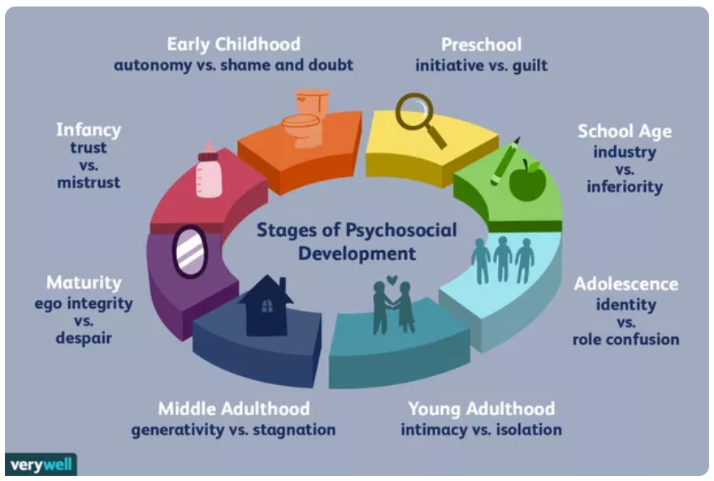

* **Component of Psychological Development**

The components of psychological development studied in this survey are as follows:

* Motivation: Motivation is the driving force behind human actions. It refers to the factors that activate humans to perform their goal direct actions. According to B.F. Skinner, “Motivation in school learning involves arousing, persisting, sustaining and directing desirable behaviour”. In the words of Woodworth, “Motivation is the state of the individual which disposes him to certain behaviour for seeking a goal”. The three major components of motivation are activation, persistence, and intensity.
* Mental Health: According to the World Health Organisation (WHO), mental health is “a state of well-being in which the individual realises his or her own abilities, can cope with the normal stresses of life, can work productively and fruitfully, and is able to make a contribution to his or her community”. Mental health can be affected by both biological factors such as family history of having mental health problems and bad life experiences. If a person’s mental health is disturbed, it can cause problems in his day to day activities, relationships and his physical health.
* Trust: According to the American Psychological Association(APA), “ In interpersonal relationships, trust refers to the confidence that a person or group of people has in the reliability of another person or group; specifically, it is the degree to which each party feels that they can depend on the other party to do what they say they will do”. In any relationship, the elements to develop trust are consistency, compassion, communication, and competency.
* Confidence: The word confidence originated from the Latin word “fiderce” which means “to trust”. Thus, confidence can be defined as “a person’s belief that a chosen course of action is the right choice and that they can properly perform that action”. The personality trait of confidence is self-confidence. There must be a balance in the confidence level of a person. Being overconfident can lead to the person being rude and arrogant. Similarly, being under confident can cause the person to miss out on opportunities, become constantly apologetic and think that they do not fit in the society.
* Learning abilities: According to Gales, “Learning is the behavioural modification which occurs as a result of experience”. Learning ability is the ability to gather knowledge at first then apply that knowledge. People with high learning ability grasp new concepts faster than people with low learning ability. Some of the ways in which learning abilities can be improved by:
  + The correct way of thinking: Having the right mindset and attitude to learn.
  + Self motivation: Motivating and Encouraging yourself to learn.
  + Learning style: Identify the learning style that best suits you and has the best outcome.
  + Learning in groups: Try learning in groups. Check if discussing concepts with your class fellows improves your learning ability.
* Emotional Development: Emotional development refers to “emergence of the experience, expression, understanding, and regulation of emotions from birth and the growth and change in these capacities throughout childhood, adolescence, and adulthood.”. Emotional Development of a person is majorly affected by his family, friends and teachers. A person has two types of emotions, positive emotions and negative emotions.
* Personal Development: Personal Development can be defined as “the conscious pursuit of personal growth by expanding self-awareness and knowledge and improving personal skills”. In simple words, personal development means developing one’s personality.
* **Overview of the Statement of the Problem:**

The purpose of the study is to examine the “impact of teachers’ behaviour on Students’ psychological development”.

The primary objectives of this study are as follow:

* Check if a teacher’s behaviour has an impact on the psychological behaviour of students.
* How different behaviours of a teacher with his students affects them.

A child is about three years old when his interaction with his teachers starts. At that stage, the mind of a child is at the start of its development. So a teacher has a direct impact on the development of a student. The interaction of a child with his teachers affects his pre-school, school age and adolescence stages of his psychological development both positively and negatively. In 1994, Wallance showed that teachers who had a positive attitude with their students improved the behaviour of students who had previous records of trouble making. On the other hand, the negative attitude of teachers with mischievous students such as making them stand outside the class worsened the behaviour of such students.

* **Correlation between Teachers’ behaviour and Students’ Psychological Development**

The survey studies the correlation between the behaviour of teachers with their students and the impact it has on seven of the components of the psychological development stated above.

* Teachers’ behaviour and Motivation of Students

The behaviour of a teacher can impact the motivation level of their students both positively and negatively. In order to maintain the motivation and goals high, a person needs reassurance that he is capable of achieving his goals. Along with reassurance, a person needs appreciation for his achievements, even if the achievements are little, to keep up his motivation. A student spends a portion of his day at the school with his teachers thus appreciation and reassurance from the teacher can help boost the motivation of a student. Similarly, lack of appreciation and reassurance from teachers might cause the students to lose their motivation. Consider the example of a student whose performance is not very good academically. Suppose he scored 10/25 marks in his first test and decides to improve his performance. In the second test he is able to improve and get 15/25 marks. If he is appreciated by his teacher on his progress, he will get motivated to improve even further for his next test. On the other hand, if the efforts of the student are not acknowledged by his teacher, his motivation might be affected by this.

* Teachers’ behaviour and Mental Health of Students
* Teachers’ behaviour and Trust of Students

A teacher’s behaviour can impact the trust of a student in other teachers. If a teacher treats the student very well and is kind to them, the students might gain trust in teachers and think that every person in the teaching profession is kind and will treat them well. Contrary to this. If a student is treated badly by a teacher, he might lose his trust for all teachers and start to think that every teacher will treat him in this way. The interaction of a student with one teacher might impact his interactions with other teachers. The impact can be both in a good way and in a bad way.

* Teachers’ behaviour and Confidence of Students

A teacher’s behaviour can impact the level of confidence of a student. If a student is constantly praised by a teacher in front of his class, he will gain confidence in himself. This confidence will also be reflected in the way he interacts with his peers. On the other hand, after constantly being scolded by a teacher, a student might begin to lose his confidence. If he is scolded in front of his class, he might feel ashamed to interact with his friends. This might lead to a student being under confident. Along with this, a teacher’s behaviour can also impact the self confidence of a student. Constant appreciation and good words can cause a student to think positively of himself and that he is capable of doing something. But if a student constantly hears insulting words from his teacher that he is not capable of achieving anything, it can cause the student to lose his confidence in himself.

* Teachers’ behaviour and Learning Abilities of Students

A teacher’s behaviour can affect the learning abilities of a student. Consider an example of a student who is creative thinking and thinks out of the box for everything taught to him. Such a student will have a lot of questions when he will be taught a new concept in the class. Another example of a student who is a slow learner and takes time to grasp new things will ask more questions as well. If both of these students are encouraged by their teacher to ask questions and those questions are answered well by his teachers, he will participate in class with more motivation. But if the teacher snubs the student to stop disturbing the class by constantly asking questions, the student will not participate in class with full motivation thus affecting his learning abilities.

* Teachers’ behaviour and Emotional Development of Students

The teachers can impact the emotional development of their students both positively and negatively. There is a chance that if a teacher is constantly in an aggressive mood while teaching the students, the students start to have aggression in their behaviour. The students can get emotions of happiness and joy if they are given a compliment by their teacher even on slightest things such as if they behaved well in class or if they performed well on a test. The students might experience emotions of sadness and fear if they are scolded by their teachers for not being able to meet their expectations or not behaving well in class. If a student is trying constantly to improve and the teacher is never happy with him, the student might feel anger for not being capable enough. Some of these emotions are felt by a student for a day or so, but sometimes the effects are long lasting.

* Teachers’ behaviour and Personal Development of Students

Teachers play a huge role in the personal development of their students. The students try to imitate the teachers they like. For example, students might copy a trait of their favourite teacher. Additionally, if a teacher always maintains an optimistic attitude with the students, the students may also become optimistic not only in their studies but in their life in general. Along with this, if the behaviour of the teacher with his students is very good in the school, the student will be satisfied while leaving the school and may carry this satisfaction throughout his day. On the other hand, bad behaviour of the teacher can affect the day to day activities of the students.

* **Conceptual Framework**

The conceptual framework of this study is as follows:

* Variables:

The variables used in this study are:

* + Independent variable: Teachers’ behaviour with their students.
  + Dependent variable: Psychological development of students.
* The method used is survey. The survey was conducted in two schools, namely “Saint Anthony School” and “Government Girls High School” of Lahore. A questionnaire consisting of 25 questions regarding teaching behaviour was provided to 50 students to fill. The results were analysed based on the answers of the students in the questionnaire.

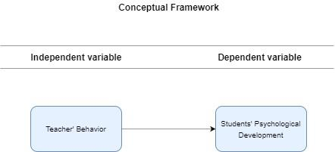

**The Impact of Teachers' Behavior on Students' Psychological and Social Development in Pakistan**

First national research paper was published on July 23, 2020. The objective of this research is to investigate the aspects that make an impact on students’ psychological and social development because of their teacher’s actions and to find out students’ psychological and socio-economic issues that infer their progress.

The sample that was collected comprised of one hundred and thirty high school students from ten schools in Faisalabad, who were asked to fill out the questionnaire. Two instructors from each school acted as observers. First of all, the questionnaire was developed and was pretested by distributing ten questionnaires. The necessary changes were done in the questionnaire to improve the questionnaire itself and to collect more valid data. Then to validate the questionnaire three-point rating scale was applied and the questionnaire that consisted of twenty-three questions was further reduced to sixteen questions. Then before the survey pilot testing was done on one hundred and thirty students to find out the reliability of the sample. This sample was not included in the final sample. Reliability coefficient was 0.87. After that the final sample for the research was collected. The final questionnaire consisted of psychological factors corporal punishment mental disturbance social media etc., and socio-economic factors like environment, relationship book learning and teacher competency.

The results collected were analyzed using frequency, standard deviation, percentage and mean. When looking at psychological factors the social media and lack of motivation were the top factors. Then comes the lack of confidence and mental disturbance. The reason that is ranked the third is poor performance in studies. Corporal punishment which is linked to psychological and behavioral changes in adults and children is identified as the fourth top factor. The fifth important factor is the need for a subject specialist and the sixth is developing phobias which is rare as per the results. Coming on to the socio-economic factors the top priority factor is the environment in which students are in school and home as both the places are key places where students get socialization and psychological grooming. The second most important factor found is the teacher’s interaction with student which directly relates with the study that we have carried out. Communication skill is the third important factor found. Fourth factor is the lack of appreciation of student by teacher as it hurts the self-esteem and confidence of a student. Fifth factor is book learning and sixth are relationship with teachers, overcrowded classes, and teacher’s competency.

In conclusion, social media is the major psychological factor that infers a students’ achievements. Secondly environment in which students are in school and home is the most important socio-economic factor that infer a student’s progress. As corporal punishment, teacher’s interaction, lack of appreciation of student by teacher is also identified as a factor that proves that teachers’ behavior does have impact on students psychological and social development.

*[1] Shazia Kausar, Rida Shoukat, Iqra Zafar , "The Impact of Teachers' Behaviour on Students' Psychological and Social Development in Pakistan," Universal Journal of Educational Research, Vol. 8, No. 12, pp. 6925 - 6931, 2020. DOI: 10.13189/ujer.2020.081259.*

**Influence of Teachers’ Behavior on students’ Academic Achievement at University Level**

This national research paper was published in 2020. The objective of this research was to look at the impact of teachers' actions on university students' academic progress and to find out if there is any relationship between academic achievements of university students and the teachers behavior.

Research hypothesis included the following:

* With respect to their demographic factors, there is no substantial difference in university students' attitudes toward their teachers' behavior.
* The comments of social sciences department students from both the universities about their lecturers' behavior are nearly identical.
* There is no link between the behavior of teachers and the academic achievement of students.
* Teachers' behavior has no impact on students' academic progress.

It is survey-based research. The respondents of the survey were one hundred and sixty-eight students from Women University Multan and three hundred and twenty-nine students from Bahauddin Zakariya University. The questionnaire consisted of forty-five questions divided into two sections that had five points Likert Scale (Strongly Disagree, Disagree, Undecided, Agree Strongly Agree) and were close ended. Section one consisted of demographic information while section two had the factors. The questionnaire covered all types of instructor behavior that students encounter at a university. Pilot study was also conducted before original survey to make sure that the instrument is reliable. Using random sampling technique three hundred and eighty-seven samples were selected from population of four hundred and ninety-seven students.

The results found out were that the attitudes of male and female students on their professors' behavior differed significantly. Furthermore, female students at both campuses were happier with their lecturers' conduct than male students. There was no discernible difference in how rural and urban children felt about their professors' behavior. Furthermore, both rural and urban kids were pleased with their professors' behavior. The pupils' attitudes on their teachers' behavior differed significantly between both the universities. Furthermore, WUM students were more satisfied with their lecturers' behavior than BZU students. The social sciences department students' judgments on their instructors' behavior differed significantly between both the universities, and the social sciences department students from both universities were satisfied with their teachers' behavior. There is a positive relationship between students CGPA and the observed factors of teachers’ behavior that included class activities negative behavior, concerned behavior and rule routine and support.

In conclusion there is a strong link between professors' behavior and university students' academic achievement so that means teachers' actions have a significant impact on students’ academic progress.

[2] Munir H., Afzal A., Arshad R., (2020). Influence of Teachers’ Behavior on students’ Academic Achievement at University Level, Journal of Arts and Social Sciences. VII (2), 60-69.

**Research on the Impact of Teacher’s Behavior on Student’s Self-Regulation**

The second international paper was published in 4th World Conference on Psychology, by Nayereh Shahmohammadi at Procedia in 2014. The objective of the research was to evaluate the impacts of The behavior of teachers specifically on self-regulation within students. More specifically, research tries to understand the factors like lack of self-esteem, issues in obeying rules, law breaking etc. within the general self-regulation. The hypothesis used in the study are as follows:

1. The student's acceptance/eagerness for discipline is favorably connected with the teacher's pleasant attitude.
2. Teacher’s amount of effort in delivering the course material and students’ self-regulation are positively correlated.
3. Teacher’s self regulation style and student’s eagerness/acceptance for discipline are positively correlated.

In order to evaluate the above mentioned hypothesis, sample of 400 students was taken. All students in the sample were from grade 6. And all students were Males. The sample was taken randomly from schools of 6 districts from Tehran.

As the primary purpose of this research is to evaluate the impacts of behavioral traits of teachers on self regulation regarding to students, the sample was divided into 208 students, who were keen towards self-regulation and 192 students, not keen towards self-regulation. Group A had student’s with self-regulation and Group B had students without self-regulation.

To evaluate the above mentioned hypothesis, the obtained results were processed using Mean, Standard Deviation, Chi Square Analysis etc. The findings of the study based on the above evaluation models are as follows:

|  |  |  |  |
| --- | --- | --- | --- |
| **Hypothesis** | **Check** | **Group A** | **Group B** |
| 1 | Mean | 3.10 | 3.45 |
| 1 | SD | 0.95 | 0.84 |
| 1 | $$x^{2}$$ | 8.81 | |

|  |  |  |  |
| --- | --- | --- | --- |
| **Hypothesis** | **Check** | **Group A** | **Group B** |
| 2 | Mean | 2.79 | 2.40 |
| 2 | SD | 0.96 | 1.08 |
| 2 | $$x^{2}$$ | 11.46 | |

|  |  |  |  |
| --- | --- | --- | --- |
| **Hypothesis** | **Check** | **Group A** | **Group B** |
| 3 | Mean | 2.82 | 2.54 |
| 3 | SD | 1.30 | 1.30 |
| 3 | $$x^{2}$$ | 10.66 | |

The results clearly reveal that for hypothesis number one, Group A students rated their teacher's behaviour as pleasant and sympathetic, but Group B students did not. In response to hypothesis number two, both Group A and Group B students stated that their teachers make every attempt to impart the course information to the students. For hypothesis number three, students in Group A felt their professors were superior to them in self-regulation, however students in Group B did not feel their teachers were superior to them.

To summarize, a supportive and honest relationship between students and teachers, the quality of teachers' self-regulative instructional methods for students, teachers' effort in clarifying course content, respect and acceptance toward students, and achievements all result in future increases in students' self-regulatory behavior.

*[1] Nayereh Shahmohammadi, "Review on the Impact of Teachers’ Behaviour on Students’ Selfregulation" 4th World Conference on Psychology, Counselling and Guidance WCPCG-2013, 2014*

**Teaching Behavior and Well-Being in Students: Development and Concurrent Validity of an Instrument to Measure Student-Reported Teaching Behavior**

The International Journal of Emotional Education published the first international research paper in November 2013. The conducted research had the objective of finding the effects of the behavior of teachers on the students and their well-being related to studies as well as their mental well-being. The research uses multiple models to effectively evaluate the factors related to the behavior patterns of the teachers, and mapping them to the impacts on the students over all well-being.

The research used a sample of 1429 students. The students were taken from grades 9 to 12 from public school level. Out of 1429 students, 1200 volunteered to participate in the research.

Sample distribution based on race/ethnicity is as follows:

|  |  |
| --- | --- |
| **Race/Ethnicity** | **Percentage** |
| Caucasians | 50.8% |
| African American | 31.6% |
| Mixed | 8.5% |
| Other | 9.1% |

Sample distribution based on gender is as follows:

|  |  |
| --- | --- |
| **Gender** | **Percentage** |
| Male | 44% |
| Female | 56% |

Sample distribution based on grades is as follows:

|  |  |
| --- | --- |
| **Grade** | **Percentage** |
| 9th | 32% |
| 10th | 28.3% |
| 11th | 15.9% |
| 12th | 23.8% |

The Institutional Review Board's permission was one of the measures performed. The parents of the kids who took part in the study received letters describing the study. In addition, the parents of the students who took part in the study gave their approval.

The parameters were used to examine the study's findings. Only 108  items were chosen out of a total of 125. Instructional Management, Negative Instructional Behavior, Social and Emotional Behaviour patterns, and Organizational Behavior were the most common items that passed the EFA and Kaiser-criterion scree test. Negative Instructional Behavior includes items such as "My teacher threatens me." Social and Emotional Behavior includes items like "My instructor smiles at me," and Organizational Behavior includes items like "My instructor tries to correct me when I behave badly." Instructional Behavior consists of items like "My instructor makes sure I understand the content prior to actually moving onto anything new." The results clearly reveal that, among the four characteristics described above, teaching behaviour has the least influence and instructional behaviour has the most influence. The remaining factors have importance score of 60% to 67%.

In a nutshell, among the four criteria described above, instructors' instructional behaviour has the greatest impact on students' well-being. Factors such as social and emotional behavior and negative teaching methods have a moderate influence on students' overall well-being, whereas Teaching Behavior has the least impact.

*[1] Patrick Pössel, Kathleen Moritz Rudasill, Jill L. Adelson, Annie C. Bjerg, Don T. Wooldridge, Stephanie Winkeljohn Black, "Teaching Behavior and Well-Being in Students: Development and Concurrent Validity of an Instrument to Measure Student-Reported Teaching Behavior" International Journal of Emotional Education, Vol. 5, No. 2.*

Total Males in Favor 441

Total Males Against 184

Total Females in Favor 525

Total Females Against 100

Overall Subject in Favor (%) = (441 + 525) = 966

966/1250 * 100 = 77.28%

Overall Subjects Against (%) = (184 + 100) = 284

284/1250 * 100 = 22.72%

## **Gender Count**

## **Do you think that teachers' behavior impacts students’ confidence?**

## **Do you think that teachers’ attitude towards students impacts their behavior?**

## **Do you think that teachers' behavior impacts students’ trust in other teachers?**

## **Do you think that teachers' behavior impacts students’ motivation?**

## **Do you think that behavior of one teacher affects the interaction of students with other teachers?**

## **Do teachers’ words about a student impact how the students think about themselves?**

## **Does constant appreciation from a teacher make a student more confident while interacting with their peers?**

## **Does lack of appreciation reduce a students’ motivation level?**

## **Does the behavior of the teacher impact the learning abilities of students?**

## **Does teachers' behavior affect a student’s emotions, both positively and negatively?**

## **Does the behavior of the teacher alter students’ behavior with their family/friends?**

## **Does demotivation to ask questions from the teacher make students hesitant to participate in class?**

## **If a teacher demotivates a student, does he/she get motivated to prove them wrong?**

## **Do students feel encouraged to learn if questions are welcomed by the teachers?**

## **Do students work with more commitment when they are praised by their teachers?**

## **Does constructive criticism by teachers enhance students’ learning abilities?**

## **Do students try to copy traits of the teachers they like?**

## **Do students become aggressive if a teacher is in a bad mood while teaching them?**

## **Do you think teachers have much influence in a student’s life, which can help or stop his/her personal development process?**

## **Does teachers’ behavior impact day to day activities of the students?**

## **Do students become more creative when they are encouraged by their teachers to think out of the box?**

## **Does constant demotivation from a teacher cause a student to lose confidence to interact with their peers?**

## **Do high expectations of teachers from their students encourage them to improve their academic performance?**

## **Do students develop optimistic traits if their teacher always have an optimistic attitude?**

## **Are social skills of students affected if they are given less attention by their teachers?**

# Interpretation of Results

According to the results of our survey **94 percent** of students of grade 9 and grade 10 have impact on their psychological development by teachers’ behavior. If we look at the results gender wise, then teachers’ behavior impact **88 percent** of male and **100 percent** of female students’ psychological development.

The outcomes demonstrates that 98 percent of the students’ confidence is impacted by teachers’ behavior, moreover 82 percent students’ behavior is impacted by teachers’ attitude towards them. 58 percent of students’ think that the behavior of their teacher impacts their trust in other teachers. Adding to it motivation of 96 percent students is affected by how teachers behave with them.

Talking about confidence of students, 80 percent students’ thinking about themselves is impacted by teachers’ words about them. When asked from students that does constant appreciation from their teacher make them more confident while interaction with their peers, 86 percent responded yes. Moreover, 92 percent students think that lack of appreciation reduce their motivation level. 78 percent of students said that demotivation to ask questions from teacher make them hesitant to participate in class discussions.

Learning abilities of students are also affected. 92 percent of students said they feel encouraged to learn if questions are welcomed by their teachers. 84 percent of students show more commitment to their work when they are praised by their teachers. When students were asked if constructive criticism by teachers enhance their learning abilities 62 percent said yes. Moreover, 90 percent of students think they become more creative when they are encouraged by their teachers to think out of the box. 76 percent of students think that their academic performance is improved by high expectations from teachers.

Personal development is another psychological development of students that get affected by teachers’ behavior with them. 56 percent of students said that they try to copy the traits of their teachers they like. 76 percent students think that they become aggressive when their teacher is in bad mood while teaching them. When asked from students whether teachers have enough influence in their life to help or stop their personal development process, 78 percent said yes.

In conclusion the results clearly indicate that teachers’ behavior does impact students psychological development that includes trust, confidence, motivation, learning abilities mental health and personal development.

About The Survey

**Purpose**

In life, we can see many students who have the knowledge to succeed but lack the proper mindset to do so. Many factors can that result in the lack of confidence of Students, including “poor treatment of students at the hands of teachers” plays an important part. This butchering of students by the hands of the same party meant to groom their personality results in the student having low self-esteem. Most students in schools of Third World go through this issue. The main purpose of conducting this survey was to ensure determine the mental health of these students to see if our modern students are receiving proper personality grooming or not.

**Hypothesis statement**

**“The teacher’s behavior impacts the psychological development of a student”.**

**Data Collection Mechanism**

In order to get students opinion as well as accurate response we conducted a survey through questionnaires. The questionnaire had a total of 25 questions and was distributed among the students personally. We made sure that the questionnaire was given to students belonging to both male and female students, so that a non-biased opinion could be collected. The time span of the completion of survey was about 3 to 4 days.

**Population Sample**

The sample space of this survey was 71 students, among which only 50 were usable. The sample included students from both Urdu-medium as well as English-medium out of which 25 were males and rest of the 25 were females. The students were between 13 to 17 years old. The survey was conducted in St. Anthony’s School Faisal town and Government Girls High School Faisal Town.